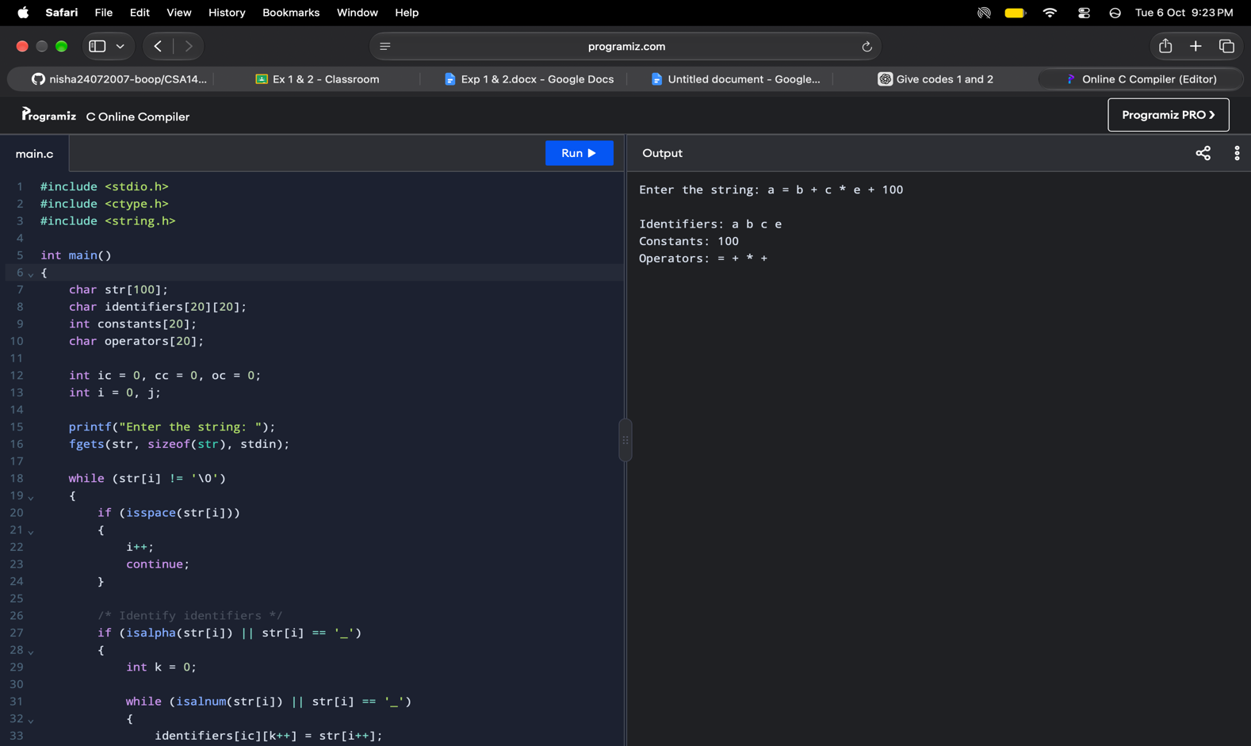
EXPERIMENT 1 – LEXICAL ANALYZER TO IDENTIFY IDENTIFIERS, CONSTANTS AND OPERATORS

